This release and additional tables
of international statistics are
available on efama’s website
(www.efama.org).

Worldwide Regulated Open-ended Fund Assets and Flows
Trends in the Third Quarter of 2018

Brussels, 18 December, 2018 – Worldwide regulated open-ended fund assets increased by 2.1 percent to EUR 46.64 trillion in Q3 2018. Worldwide net cash flow to all funds amounted to EUR 169 billion, compared to EUR 193 billion in Q2 2018.

The information presented in this report was compiled by EFAMA and the Investment Company Institute (ICI) on behalf of the International Investment Funds Association (IIFA), an organization of national investment fund associations. Statistics from 47 countries are included in this report.

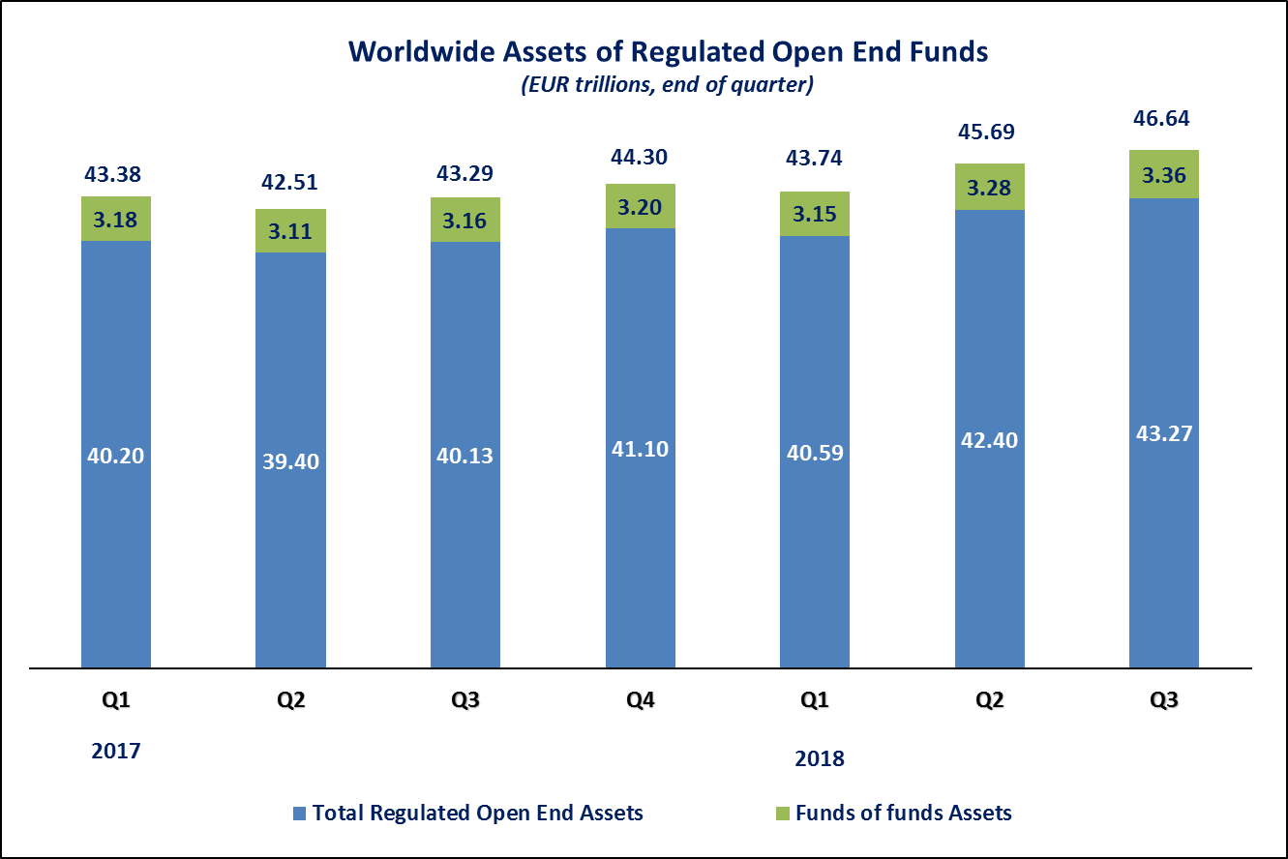

Measured in U.S. dollars, worldwide investment fund net assets increased to USD 54 trillion at the end of Q3 2018. This represented an increase of 1.5 percent, compared to an increase of 2.1 percent on a euro-denominated basis. The following two graphs compare the net asset growth in the seven largest countries/regions.

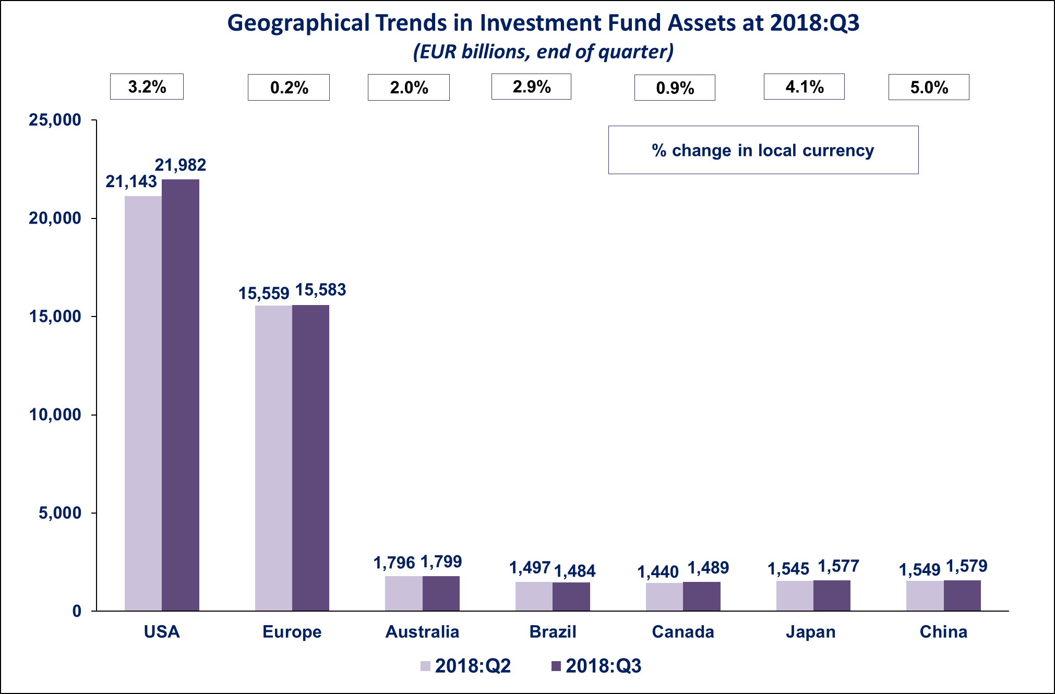

On a euro-denominated basis, worldwide equity fund assets increased by 3.5 percent to EUR 19.9 trillion at the end of Q3 2018. Bond fund assets increased slightly to EUR 9.3 trillion. Balanced/mixed fund assets increased 1.5 percent to EUR 8 trillion. Money market fund assets also increased from 5.1 trillion in Q2 to 5.2 trillion at the end Q3 2018.

At the end of Q3 2018, 43 percent of worldwide regulated open-ended fund net assets were held in equity funds. The asset share of bond funds was 20 percent and the asset share of balanced/mixed funds was 17 percent. Money market fund assets represented 11 percent of the worldwide total.

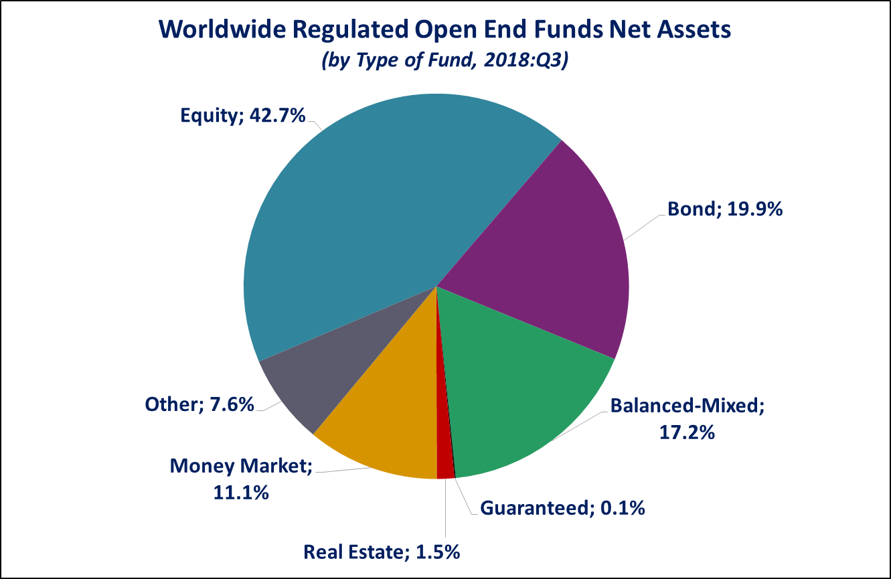

Looking at the worldwide distribution of investment fund net assets at end Q3 2018, the United States and Europe held the largest shares in the world market, with 47.1 percent and 33.4 percent, respectively. Australia (3.9%), China (3.4%), Japan (3.4%), Brazil (3.2%), Canada (3.2%), Rep. of Korea (0.9%), India (0.5%) and South Africa (0.4%) follow in this ranking.

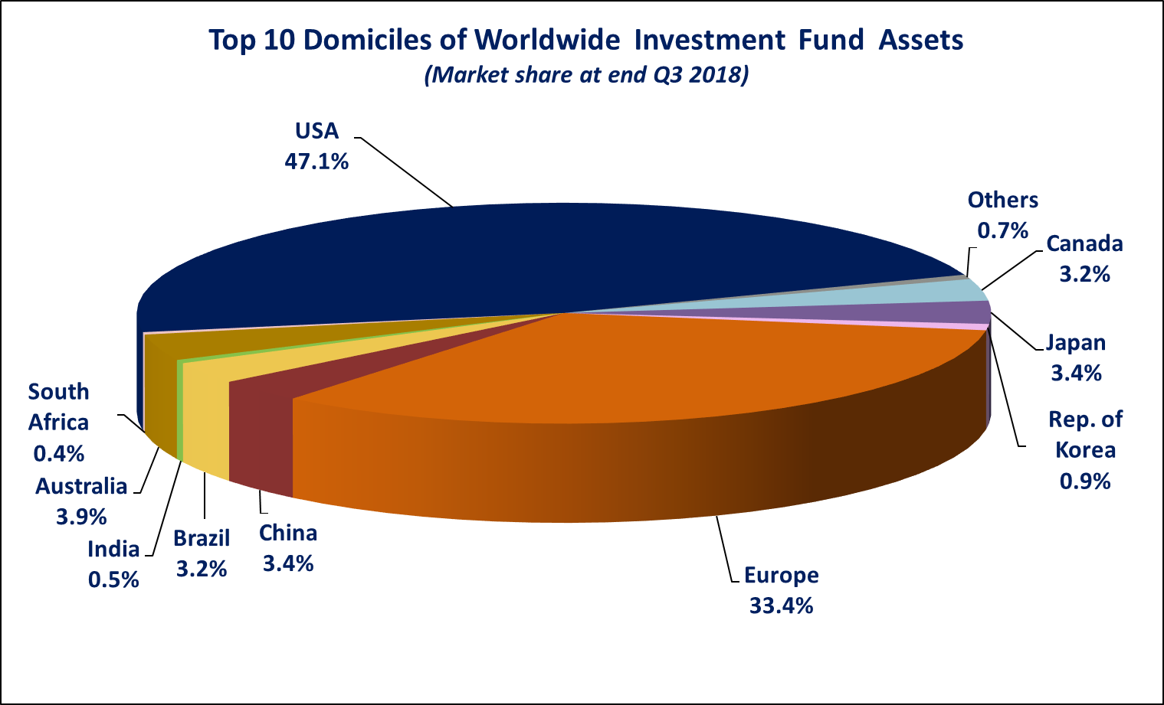

Overall, five European countries ranked among the top ten largest fund domiciles: Luxembourg (with 9.2 percent of worldwide investment fund assets), Ireland (5.4%), Germany (4.5%), France (4.1%), and the United Kingdom (3.6%).

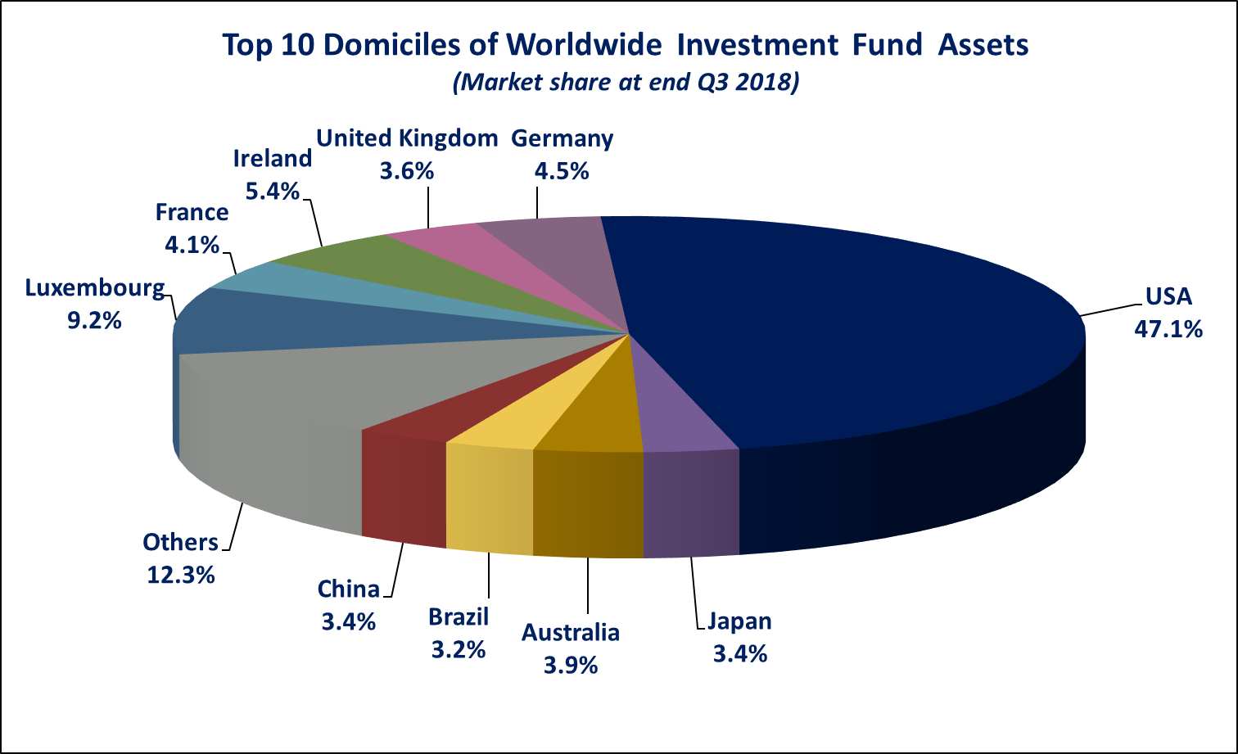
Worldwide net sales of regulated open-ended funds amounted to EUR 169 billion in Q3 2018, compared to EUR 193 billion in Q2 2018. Long-term funds recorded net sales of EUR 215 billion, up from EUR 162 billion in the previous quarter. Globally, equity funds recorded net sales of EUR 83 billion in Q3 2018, compared to EUR 38 billion in Q2 2018. Bond funds recorded net sales of EUR 78 billion, up from EUR 61 billion in the previous quarter. Net sales into balanced/mixed funds worldwide totalled EUR 19 billion, down from EUR 26 billion in Q2 2018. Money market funds worldwide recorded net outflows of EUR 46 billion, compared to net inflows of EUR 31 billion in the previous quarter.

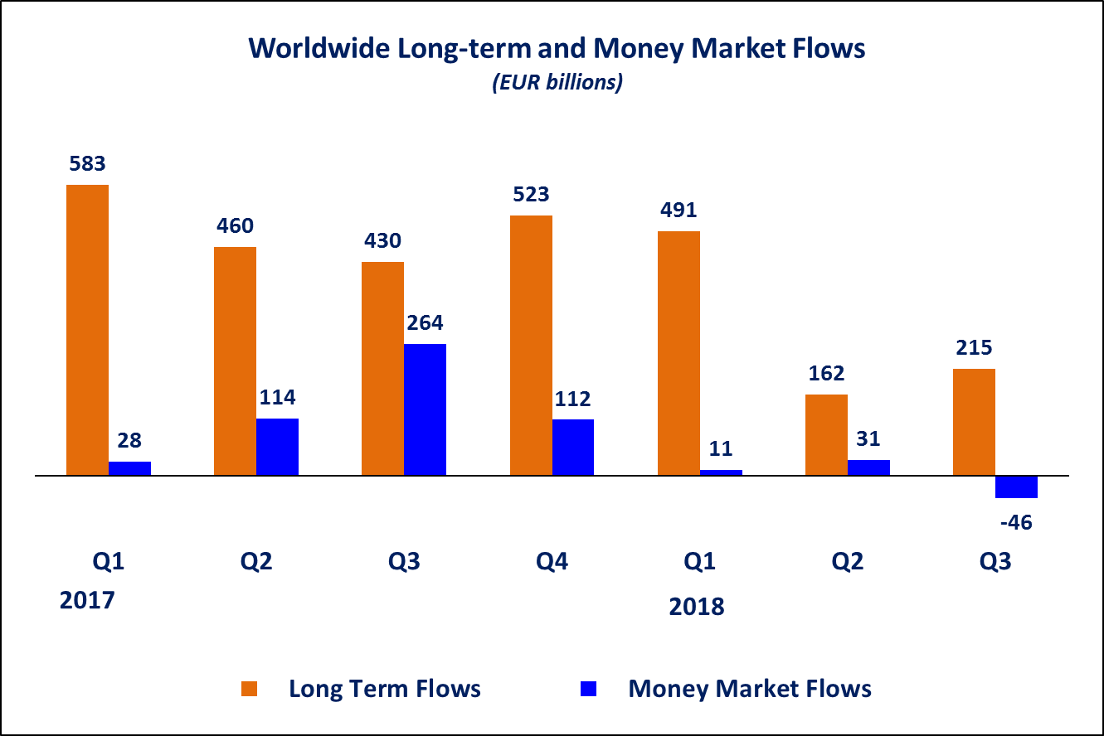
Net sales of regulated open-ended funds reached EUR 119 billion in the United States, EUR 50 billion in Europe, EUR 35 billion in Japan and EUR 10 billion in Canada. Emerging markets registered net outflows of EUR 46 billion (of which net outflows of EUR 36 billion in China and EUR 11 billion in India). The United States, Europe, Japan and Canada all experienced an increase in net sales compared to Q2 2018.

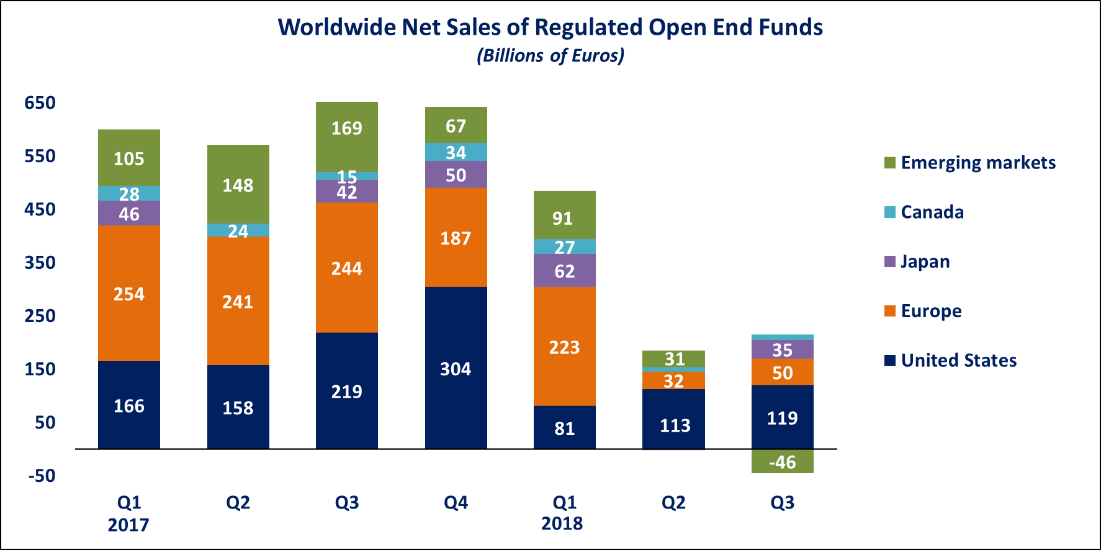

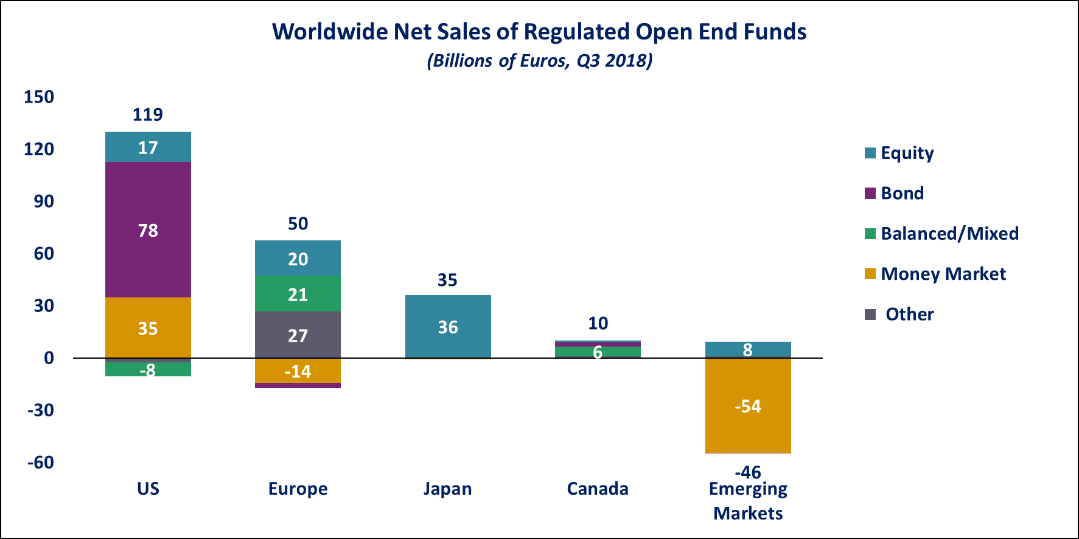
In Europe, long-term funds attracted net sales of EUR 65 billion, up from EUR 48 billion in Q2 2018. Equity funds recorded net sales of EUR 20 billion, compared to EUR 0.5 billion in Q2 2018. Bond funds recorded net outflows of EUR 3 billion, compared to net outflows of EUR 6.5 billion in the previous quarter. Net inflows into balanced/mixed funds amounted to EUR 21 billion, down from EUR 25 billion in Q2 2018. Money market funds recorded net outflows of EUR 14 billion, compared to net outflows of EUR 19 billion in Q2 2018.

In the United States, long-term open-ended funds recorded net sales of EUR 85 billion, compared to EUR 91 billion in Q2 2018. Equity funds recorded net sales of EUR 17 billion, compared to EUR 25 billion in Q2 2018. Net sales of bond funds increased from EUR 69 billion in Q2 2018 to EUR 78 billion in Q3 2018. Balanced/mixed funds registered net outflows of EUR 8 billion, compared to net outflows of EUR 4 billion in the previous quarter. Money market funds recorded net inflows of EUR 35 billion, compared to EUR 23 billion in Q2 2018.

Regional Summary Table by Type of Fund, Q3 2018

All data presented in this report include funds of funds, exchange-traded funds and institutional funds.

