Press Release
For immediate release

European assets under management have more than doubled in the last decade
EFAMA publishes the 11th edition of its annual Asset Management Report

Brussels, 17th September 2019: The European Fund and Asset Management Association (EFAMA) has published today the 11th edition of its Asset Management Report. The report aims to highlight the fundamental role of asset managers in the financial system and wider economy, channelling savings of European citizens towards investments and putting these savings to work productively for the economy.

The report provides detailed data on the assets under management in Europe, the location of the asset management activity, the clients of the industry, the evolution of the asset allocation, and the contribution of the industry in terms of employment.

Highlights of the report include:

- Total Assets under Management (AuM) in Europe is estimated at EUR 23.1 trillion, an increase of 113% since end-2008. Investment funds assets represented EUR 12.5 trillion (%) - 54% of total AuM - with discretionary mandates accounting for the remaining EUR 10.6 trillion. Although down from 2017 due to the sharp decline in global stock markets towards the end of 2018, total assets have more than doubled from the lows they reached during the global financial crisis of 2008.

- Since 2011, the share of investment funds in total AuM has risen every year. This has occurred largely as a result of the much higher proportion of equities in the portfolio allocation of investment funds (42% of total investment funds AuM) than in mandates (22% of discretionary mandates AuM) - coupled with the strong rise of stock markets over the 2012-2017 period. The increase in the share of investment funds in the portfolio allocation of pension funds and insurance companies has also played a role in this evolution.

- Three countries hold a significant market share in assets under management in Europe: the UK (37%), France (17%) and Germany (9%). These high market shares reflect the size of these countries’ economies, their experience in financial services as well as their pool of savings accumulated over the years.

- In most European countries, the asset management industry serves predominantly domestic clients. The UK is the main exception with 40% of AuM managed on behalf of foreign clients.

Tanguy van de Werve, Director General of EFAMA, comments:

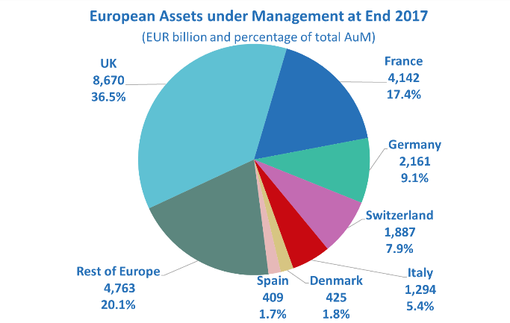
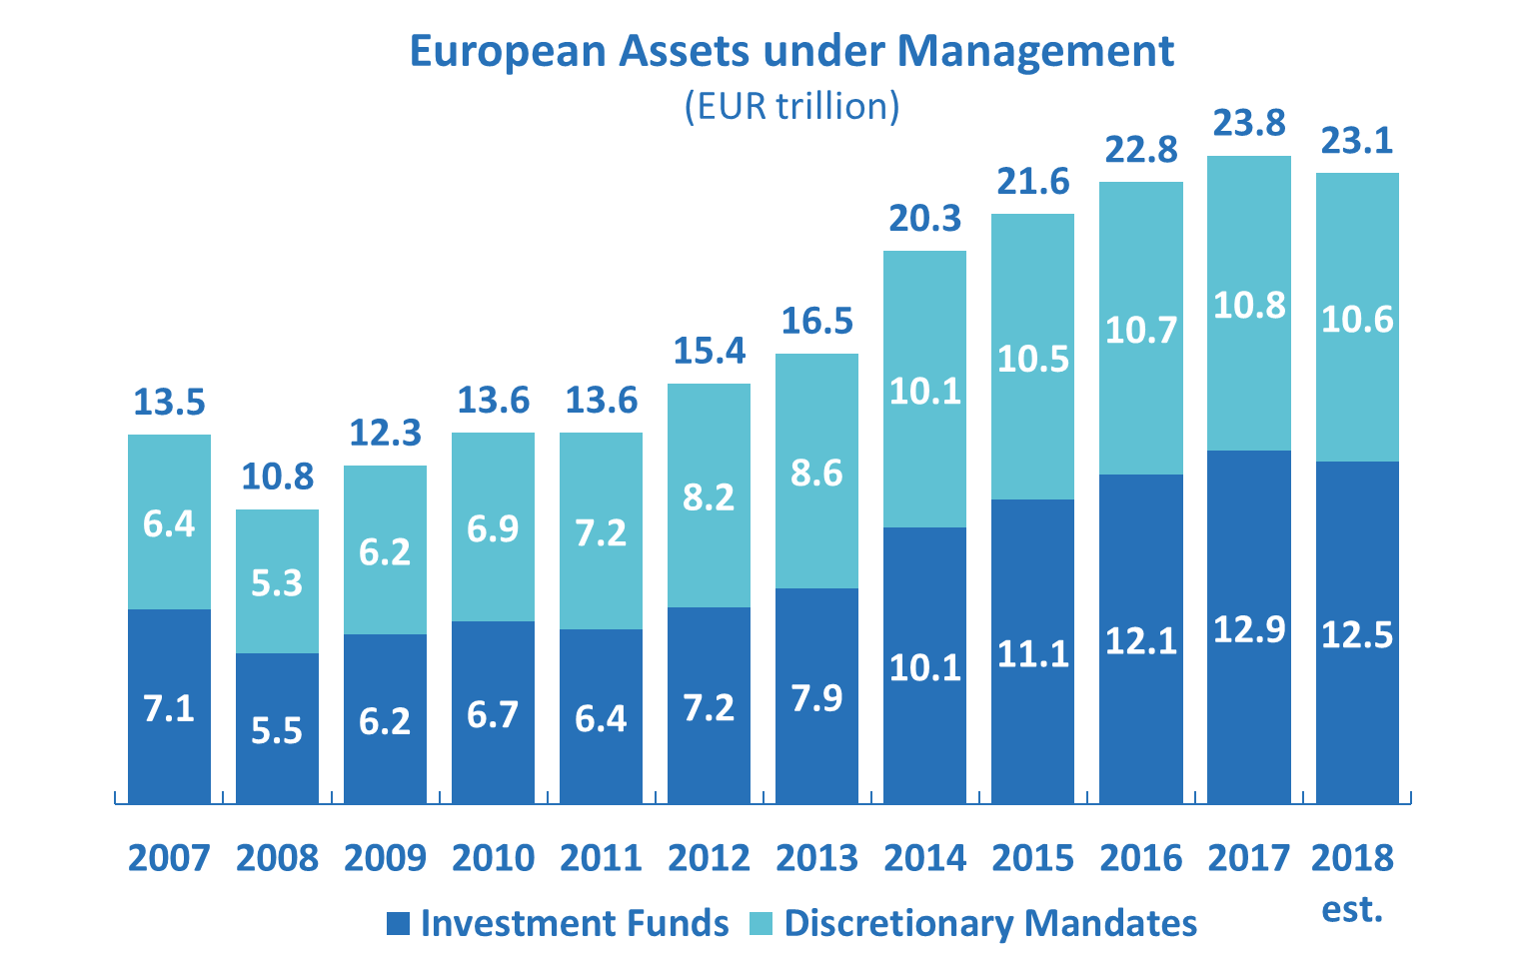
“This latest edition of EFAMA’s Asset Management Report highlights the important role played by the European asset management industry in managing investments on behalf of European citizens and institutional investors. The observed continuing increase in the share of investment fund assets in the total assets managed in Europe confirms the success of UCITS as a global brand and the quality of the regulatory framework for the management of alternative investment funds (AIFs). The overall ecosystem created to support the operations of UCITS and AIFs on a cross-border basis, including the well-functioning model of delegation and the flexibility offered to outsource back-office functions, has allowed to benefit from the best expertise available and played an essential part in the global acceptance of UCITS and AIFs. Ensuring the continued success of these investment vehicles should be a strategic goal for the new European Commission, and an integral part of the plan to create a well-functioning Capital Markets Union.”

– Ends –

For media enquiries, please contact:

Tanguy van de Werve, Director General
Bernard Delbecque, Senior Director for Economics and Research
Telephone: +32 (0) 2 513 39 69
E-mail: info@efama.org

Notes to editors:

About the EFAMA Asset Management Report:

Twenty EFAMA national member associations provided data on the value of the assets managed in their countries at end 2017: Austria, Belgium, Bulgaria, Croatia, the Czech Republic, Denmark, Finland, France, Germany, Greece, Hungary, Italy, the Netherlands, Poland, Portugal, Romania, Slovenia, Switzerland, Spain, Turkey and the UK. According to our estimation, these countries account for 87% of the assets under management (AuM) in Europe. Additional internal and external data have been used to estimate the AuM in the other European countries.

The focus of the report is to analyze figures on the asset management industry from the perspective of where the assets are managed. This approach is different from the point of view taken in the other publications of EFAMA, which report investment funds data on the basis of their country of domiciliation.

